Implement Security Scanning in Pipelines

Overview

Modern software development is moving rapidly, and with this pace comes an increased risk of introducing security flaws into applications. Organizations are no longer waiting until production to test for vulnerabilities. Instead, they practice DevSecOps — integrating security checks directly into the software development lifecycle (SDLC).

This documentation demonstrates how to implement Security Scanning in a CI/CD pipeline using GitHub Actions.
We will integrate two industry-standard security practices:

- SCA (Software Composition Analysis):
  - Focuses on dependencies and libraries.
  - Ensures no vulnerable third-party package enters the project.
  - Implemented using GitHub Dependency Review Action.
- SAST (Static Application Security Testing):
  - Focuses on source code analysis.
  - Detects security flaws like SQL injection, unsafe function calls, or hardcoded secrets.
  - Implemented using GitHub CodeQL.

Prerequisites

- GitHub account with permission to create repositories.
- Basic knowledge of GitHub concepts: repositories, branches, pull requests.

Step 1: Create a Repository

- Go to Github Click “Sign in”

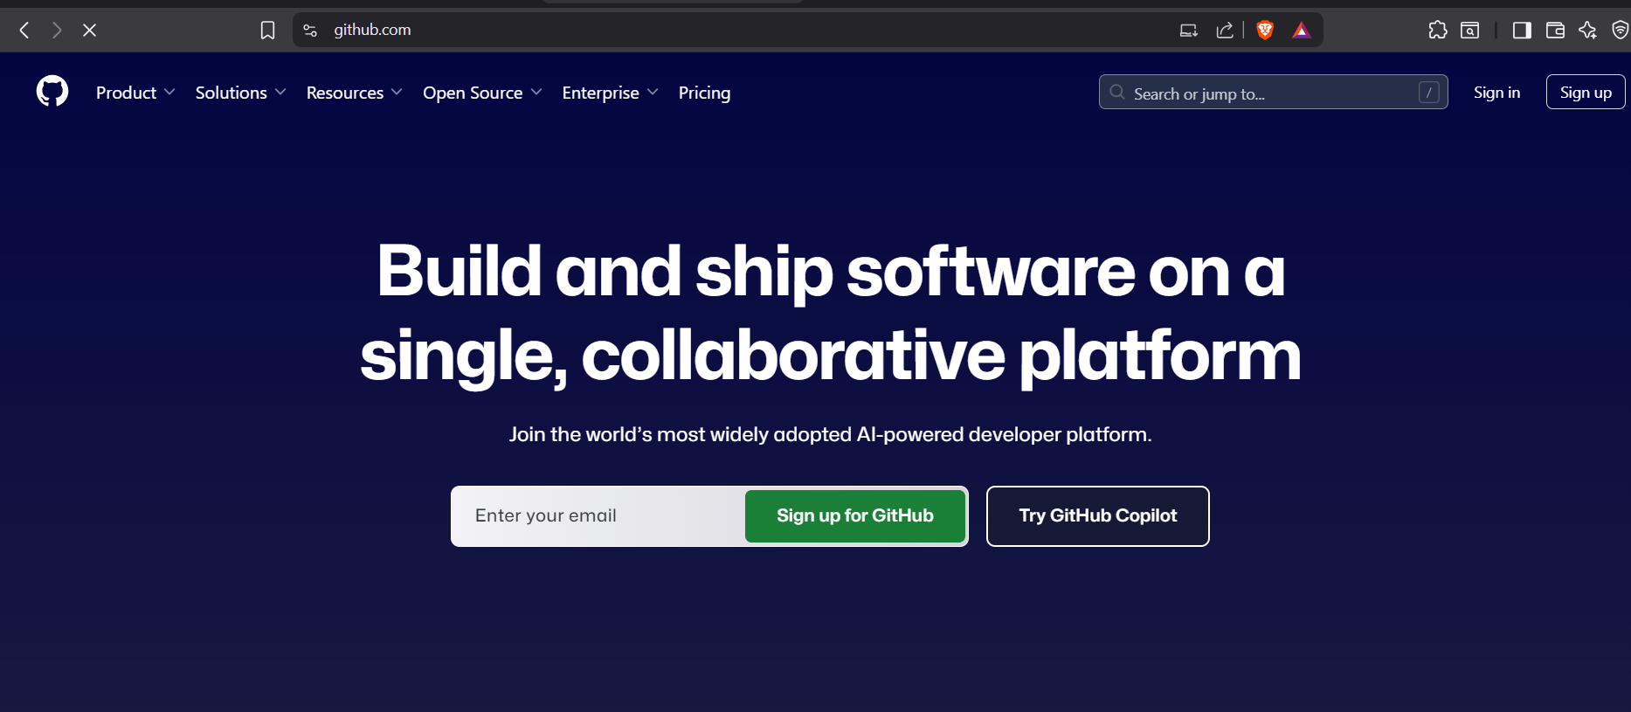

- Sign in to your GitHub account.

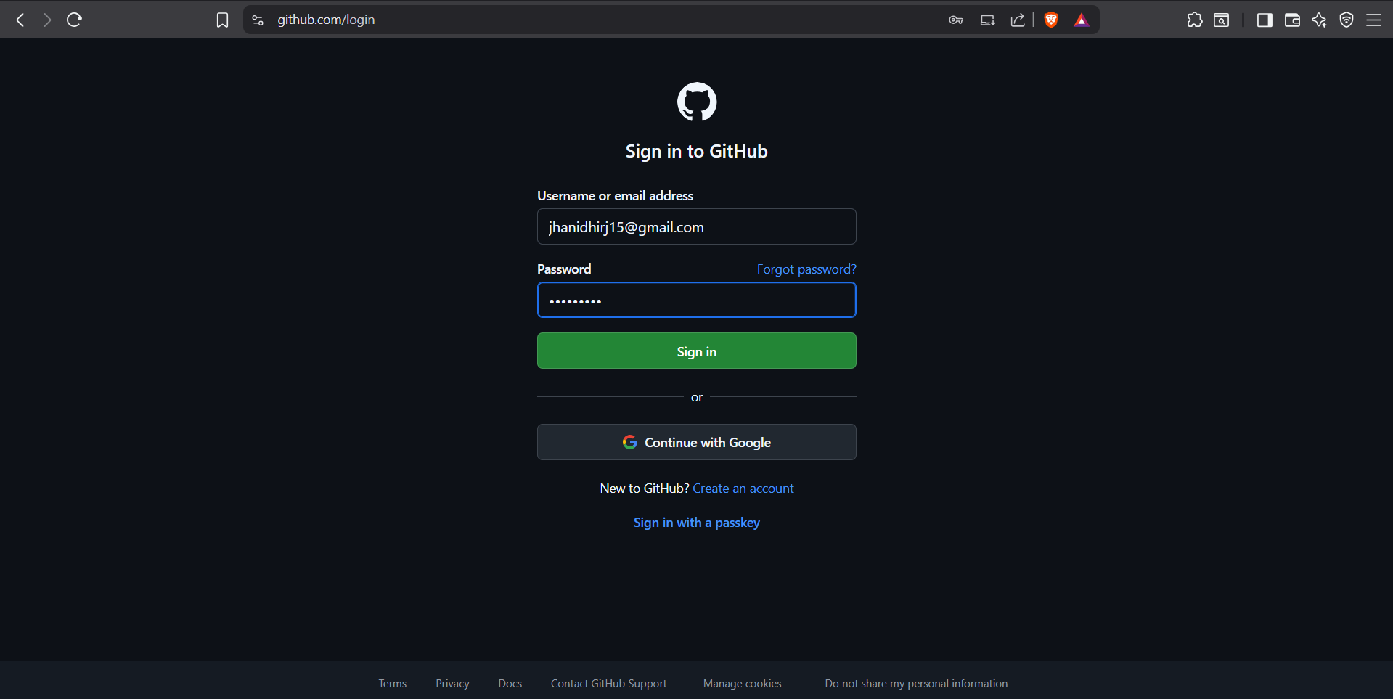

- Click the green "New" button to create a new repository.

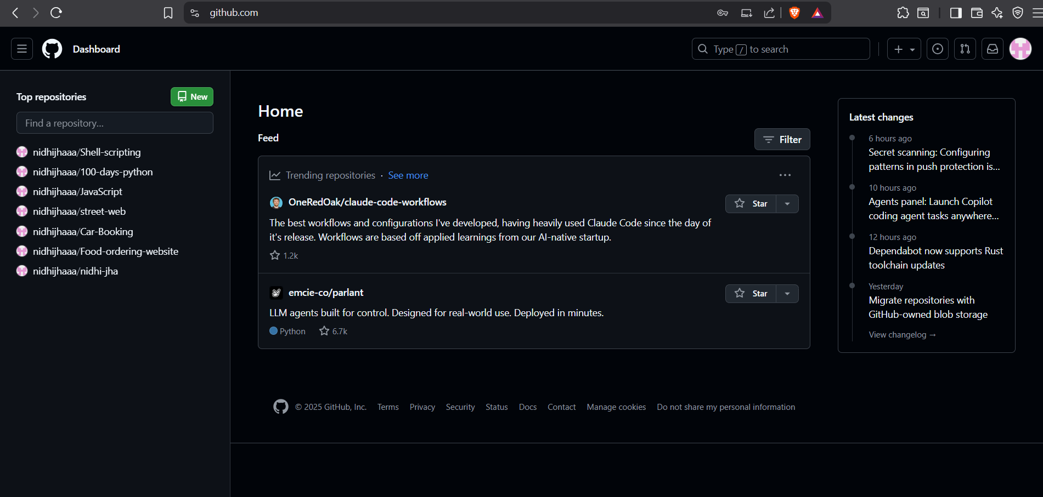

- Name it: my-security-project
- Set it to Public (so all free features work).
- Check the box for "Add README"

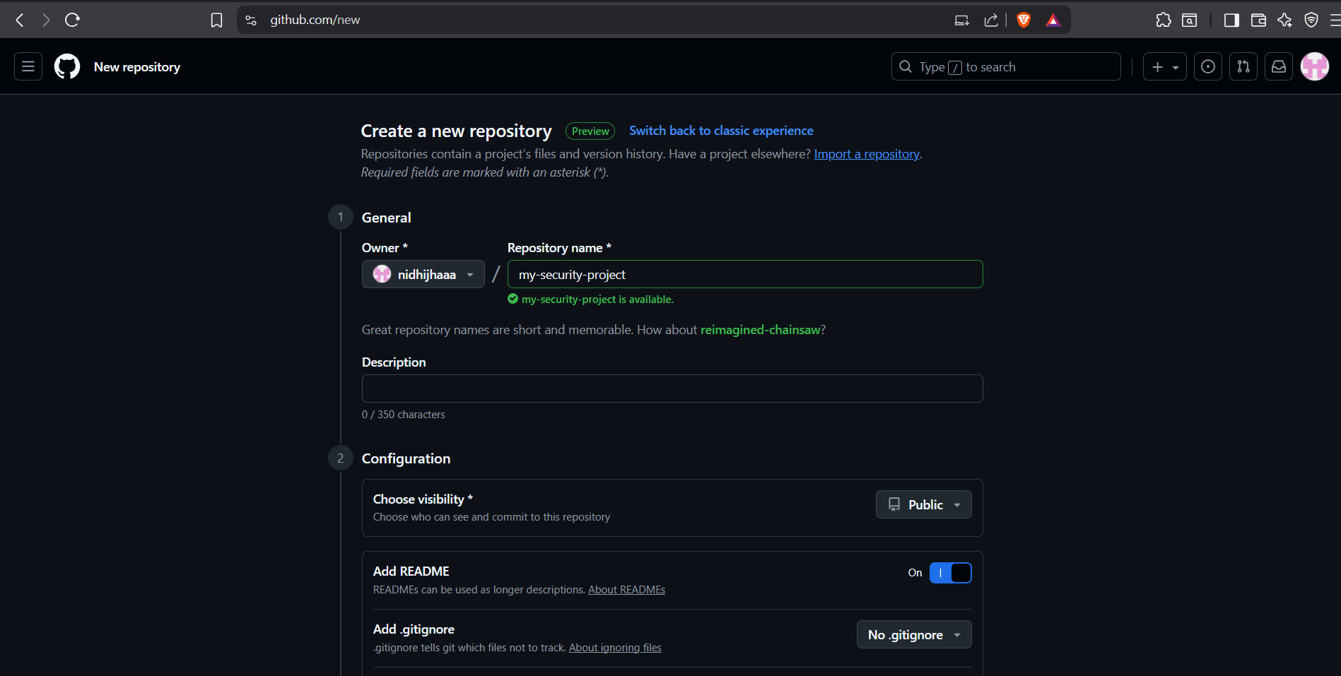

- Click "Create repository".

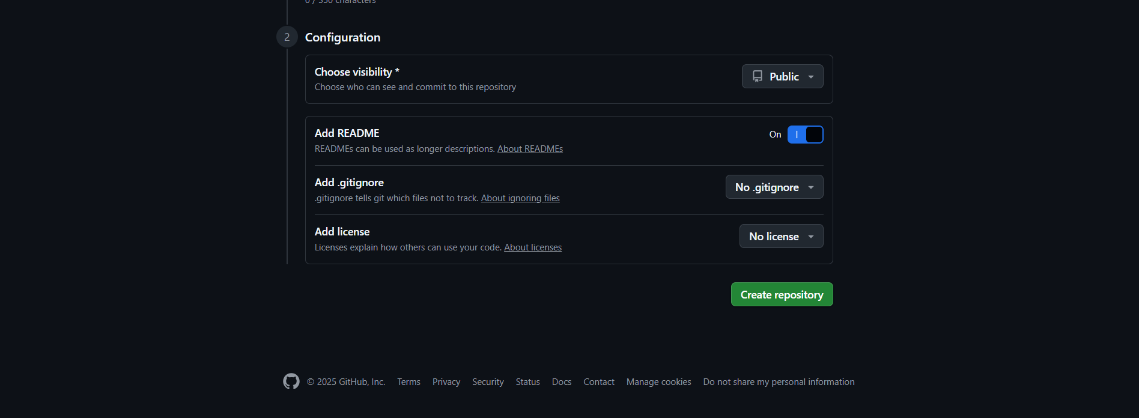

Repository created.

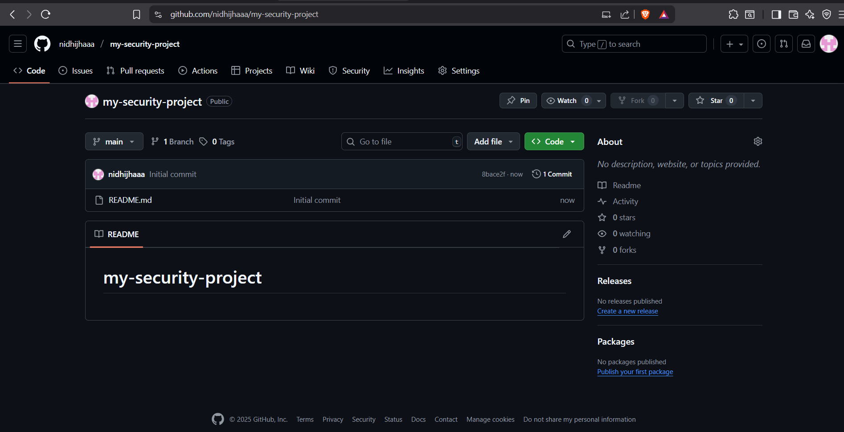

Step 2: Add a package.json File

- On your new repository's main page, click the "Add file" "Create new file" button

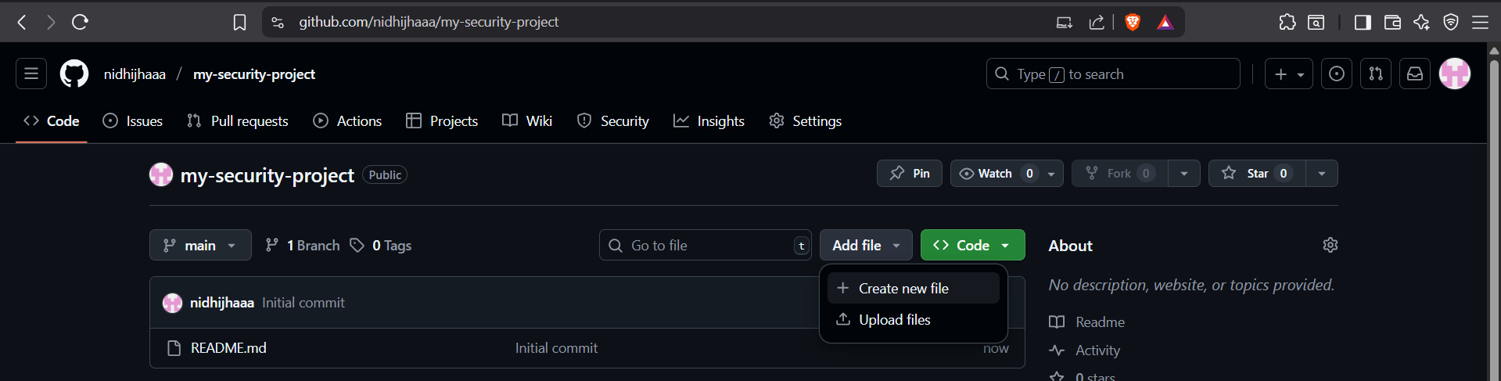

- Name the file package.json

Copy and paste the following code into the file content area:

{

"name": "my-security-project",
"version": "1.0.0",
"description": "A sample project to test security scanning",
"main": "index.js",

"scripts": {
"test": "echo \"Error: no test specified\" && exit 1"
},

"dependencies": {
"express": "^4.18.0",
"lodash": "^4.17.0"
},

"author": "",
"license": "ISC"

}

- Click on “Commit changes”.
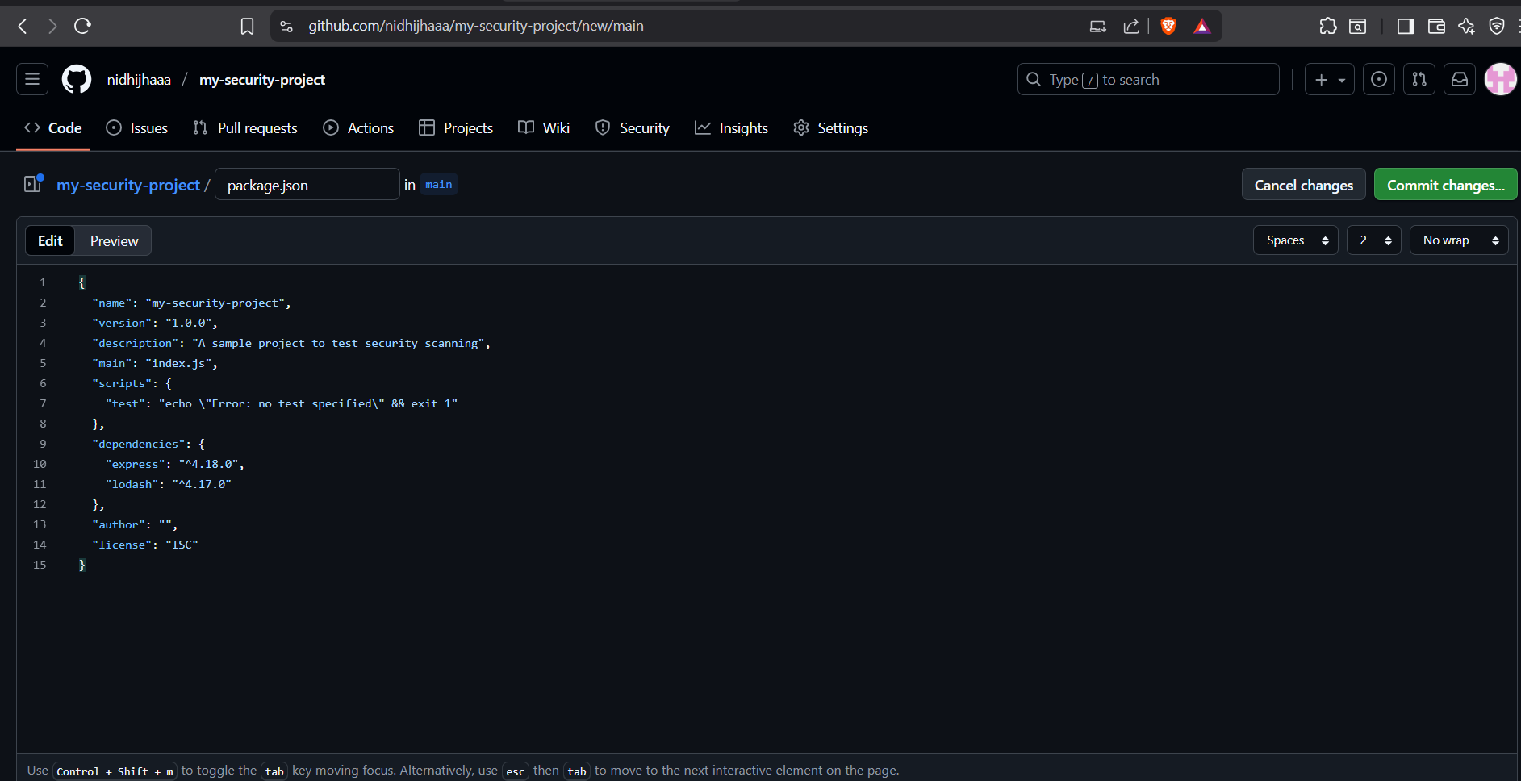

- Type a message like Add package.json.
- Click the green "Commit changes" button.

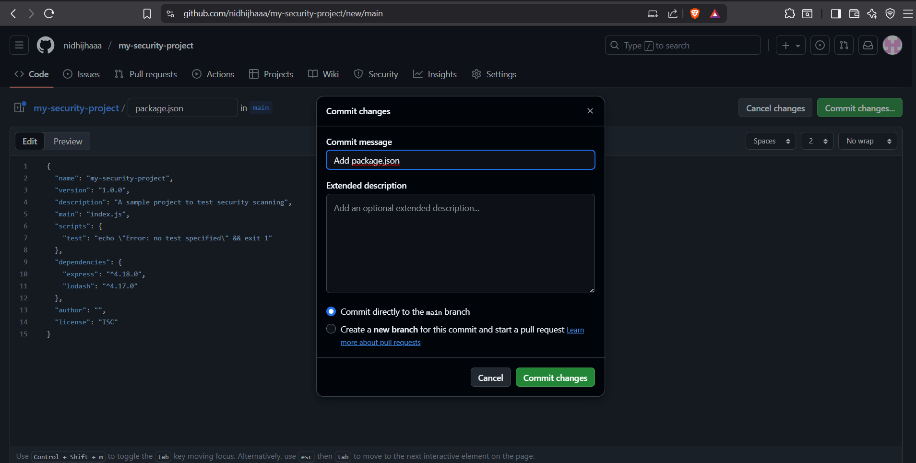

- Committed successfully.
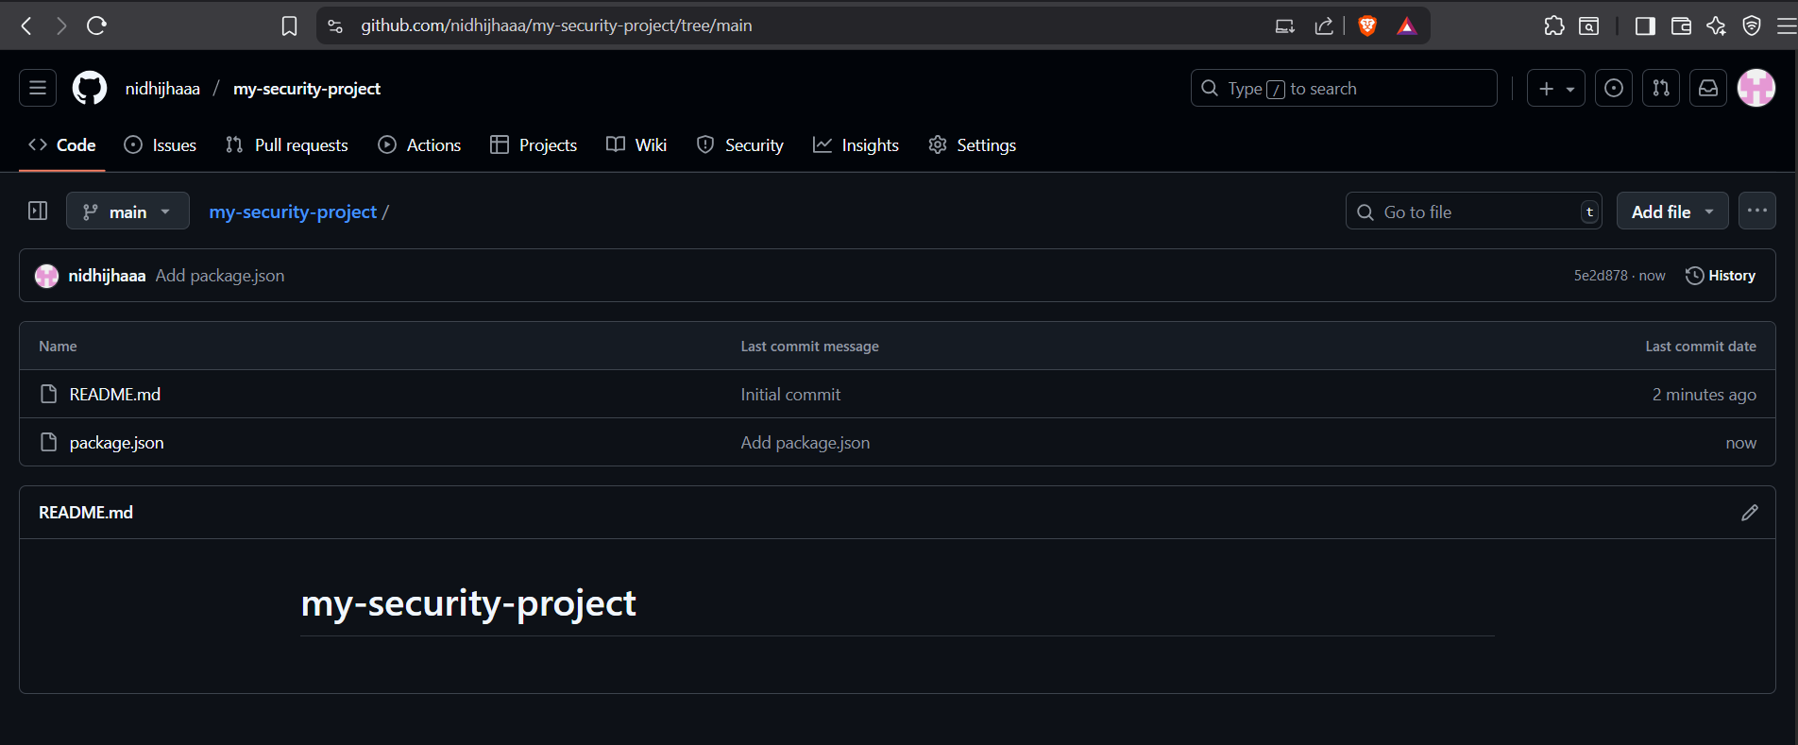

Step 3: Create the Security Workflow

- From your repository's main page, click the "Add file" > "Create new file" button again.

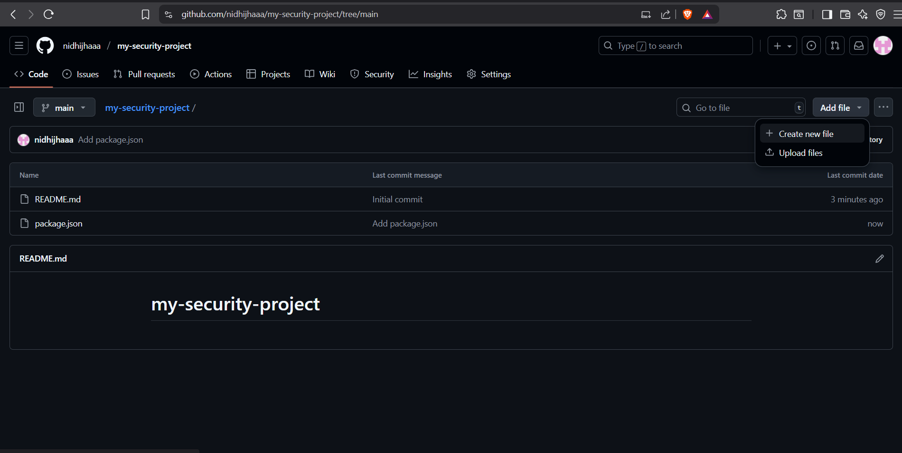

- Create a file.
- This is crucial: name the file .github/workflows/security.yml

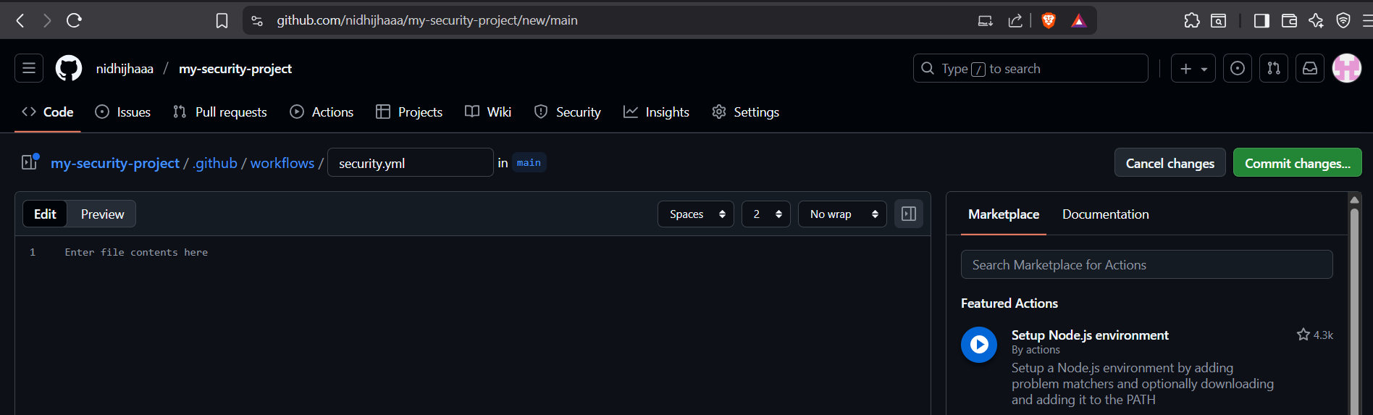

- Copy and paste the entire code below into the big text box

name: Security Scanning (SAST & SCA)

on:
pull_request:
branches: [ "main" ]

jobs:
dependency-scan:
runs-on: ubuntu-latest
steps:
- name: Checkout code
uses: actions/checkout@v4

- name: Set up Node.js
uses: actions/setup-node@v3
with:
node-version: '18'

- name: Install dependencies
run: npm install

- name: Run Dependabot SCA scan
# ONLY run this step if the event is a pull_request
if: github.event_name == 'pull_request'
uses: actions/dependency-review-action@v3

codeql-sast-scan:
runs-on: ubuntu-latest
permissions:
security-events: write
actions: read
contents: read
steps:
- name: Checkout code
uses: actions/checkout@v4

- name: Initialize CodeQL
uses: github/codeql-action/init@v2
with:
languages: javascript

- name: Perform CodeQL Analysis
uses: github/codeql-action/analyze@v2

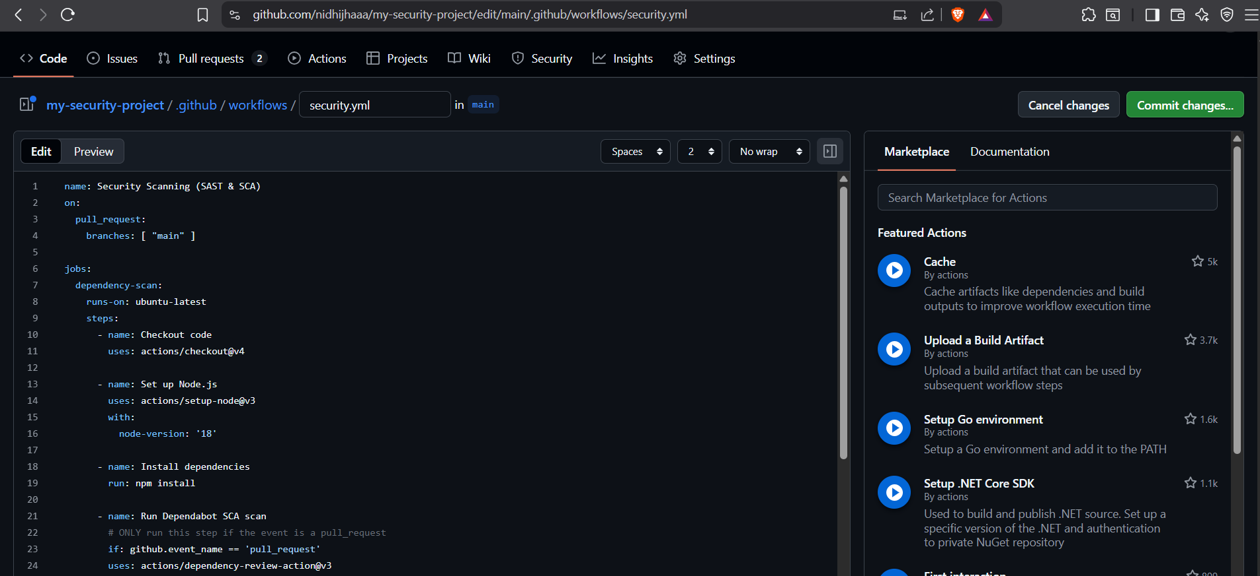
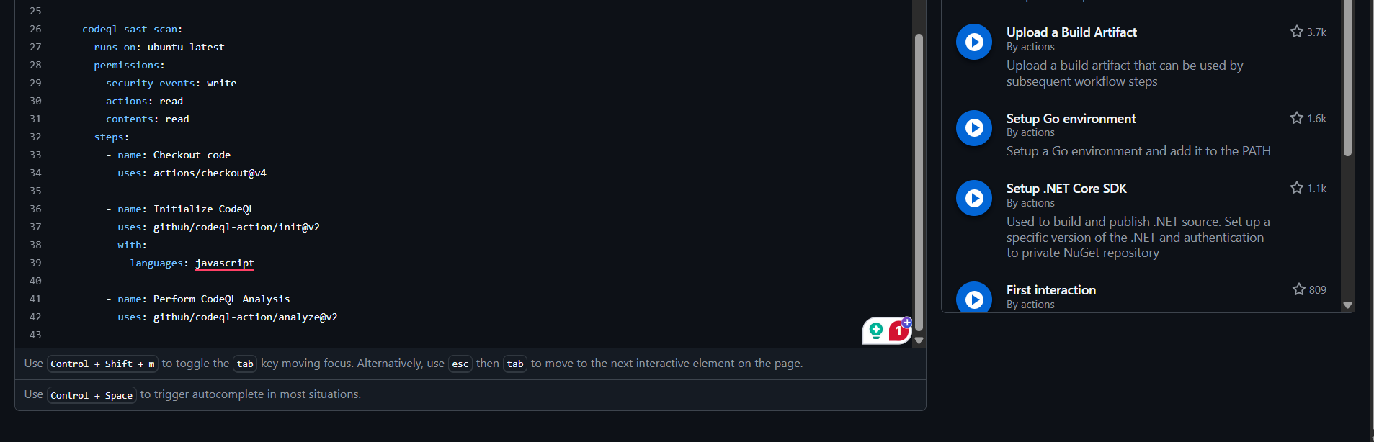

- Commit message: "Add initial security scanning pipeline"
- Click the green "Commit changes" button.

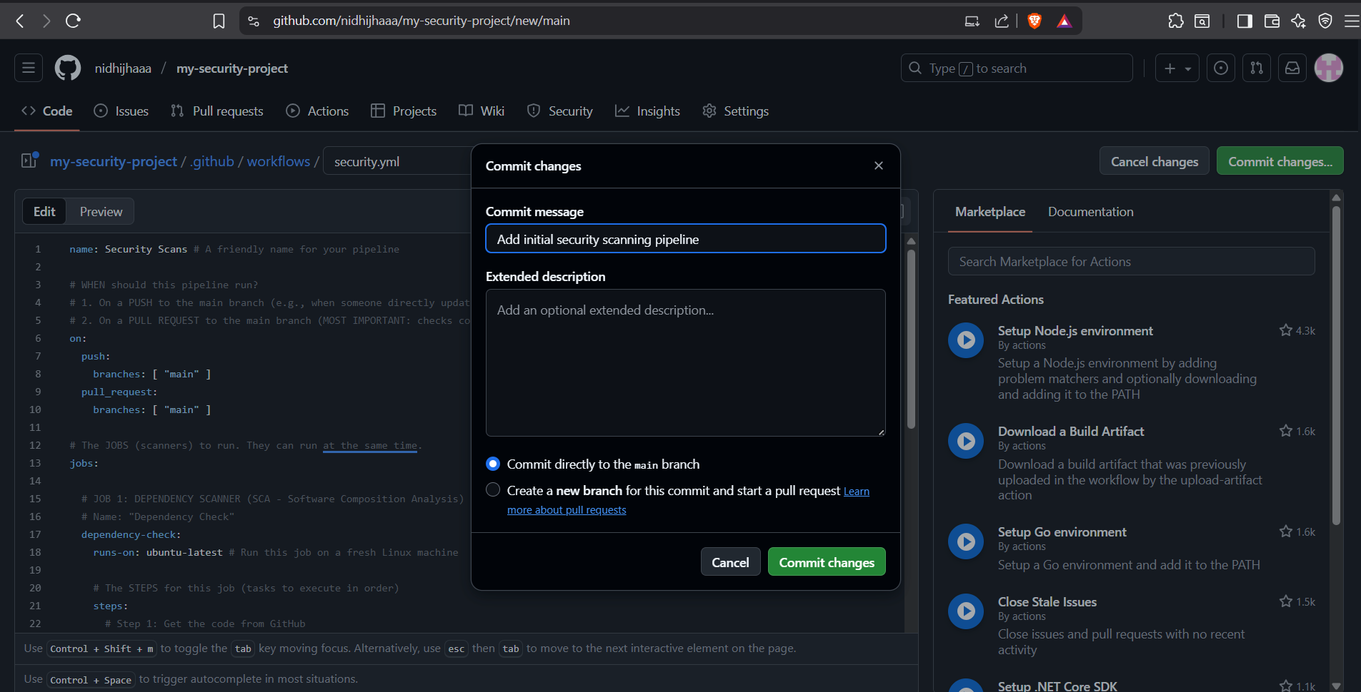

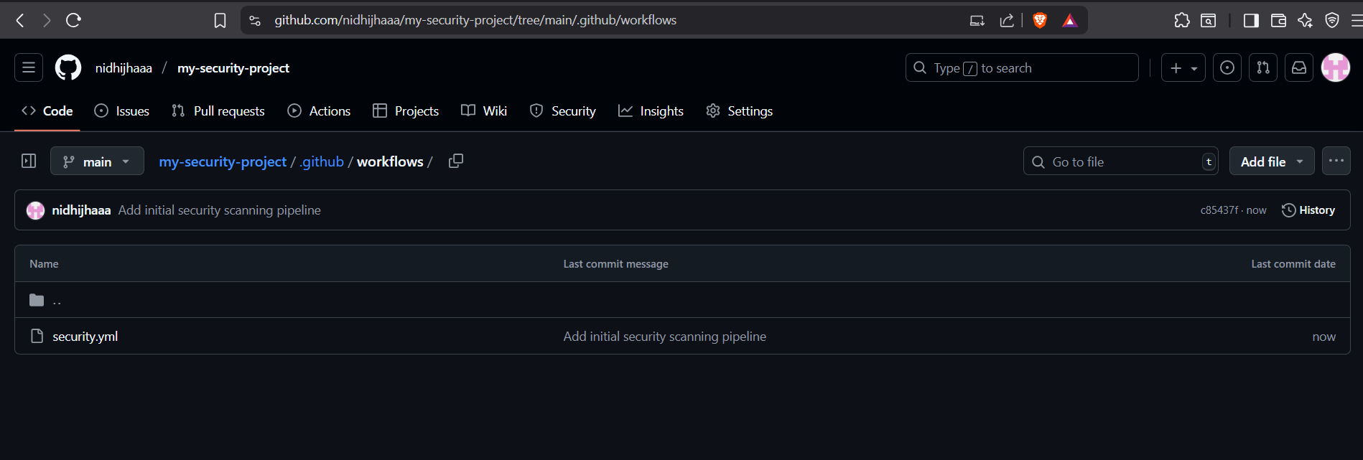

Step 4: Enable Dependency Graph

- Navigate to Settings
- Enable Dependency Graph

(Dependency Graph is required for SCA. It keeps track of all the libraries in your project and checks them against GitHub’s vulnerability database.)
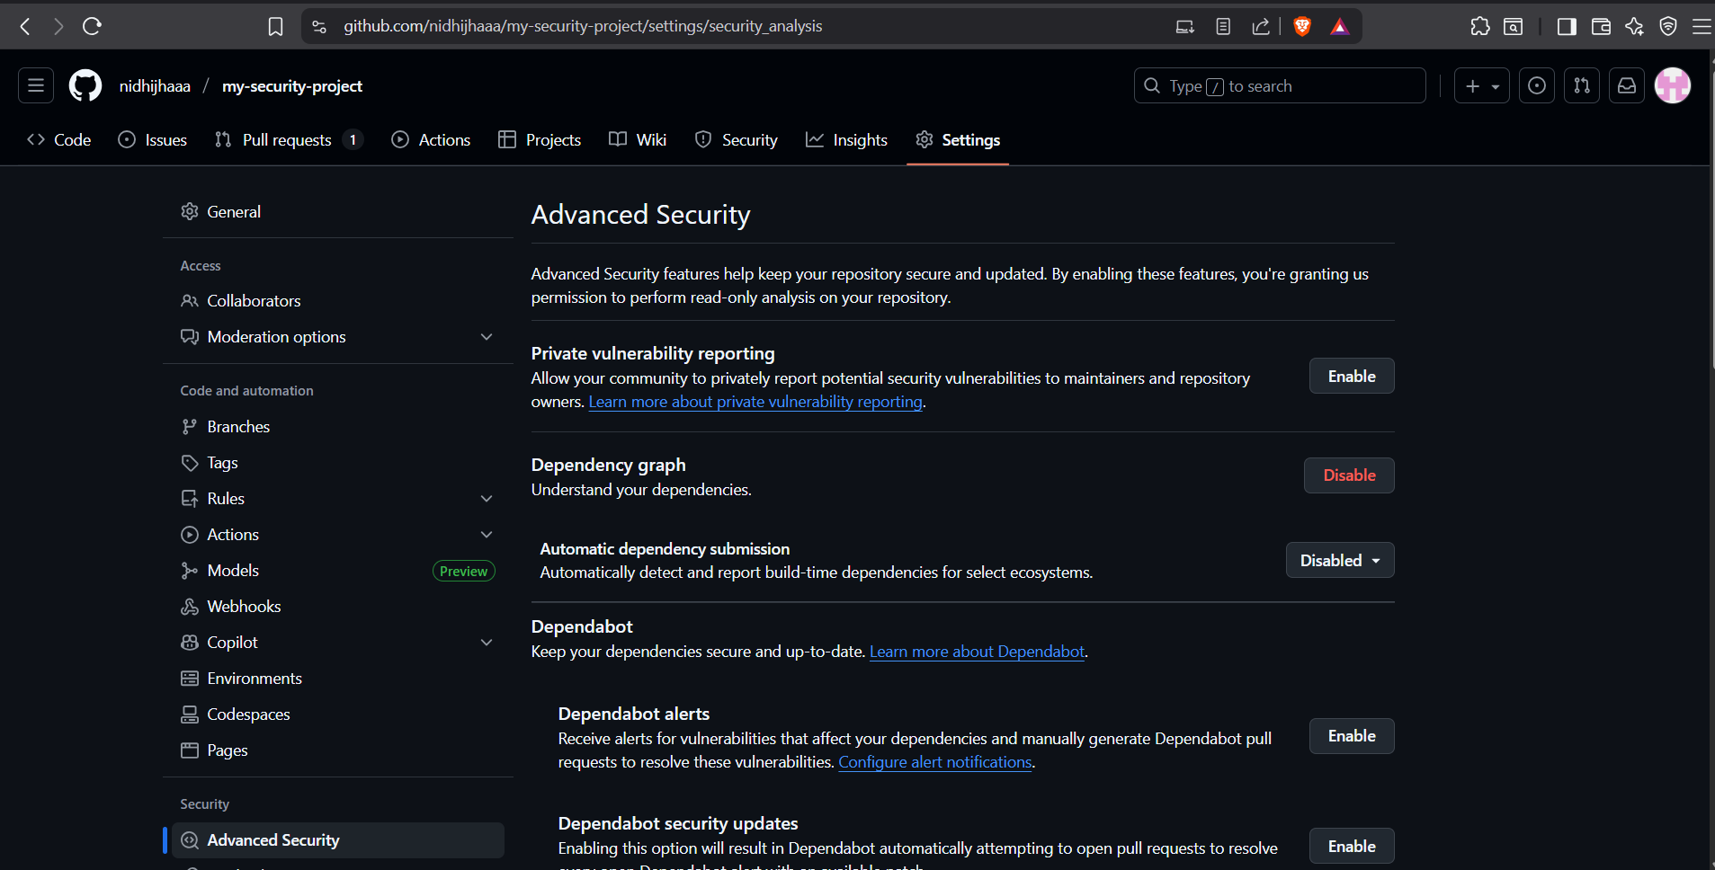

Step 5: Testing the Pipeline

Test That It Works
We will create two Pull Requests (PRs):
- Test 1 (The Good PR): A simple, safe change. We expect all checks to pass.
- Test 2 (The Bad PR): A change that introduces a known vulnerable library. We expect the Dependency Scan to FAIL and block the merge.

Test 1: The Good PR (Should PASS)

- Click the "Add file" button and select "Create new file".

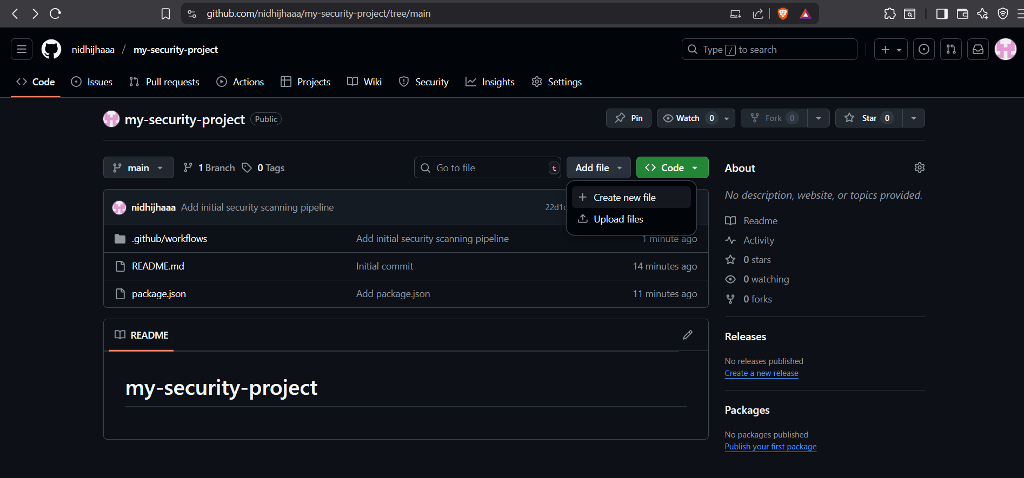

- Name the file test.txt.
- Add any simple content

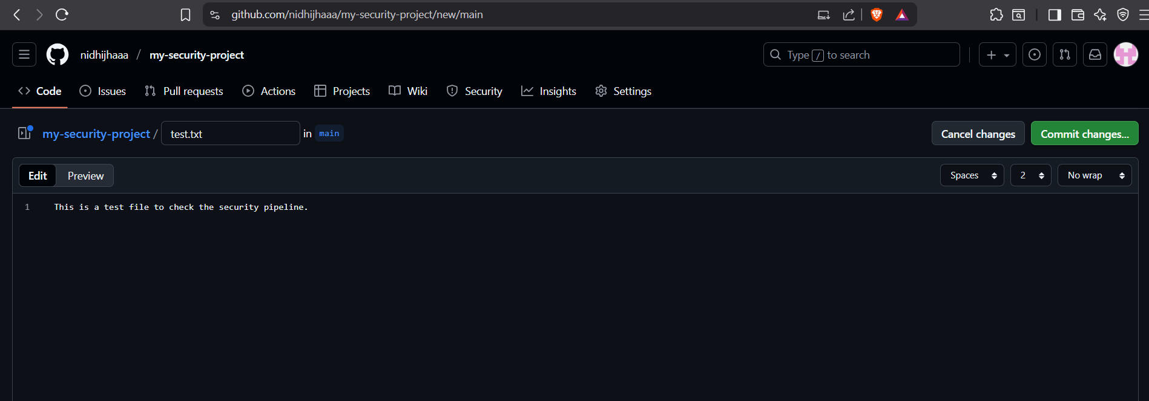

- "Create a new branch for this commit and start a pull request."
- Name the new branch something like test/good-change.
- Click the green "Propose changes" button.

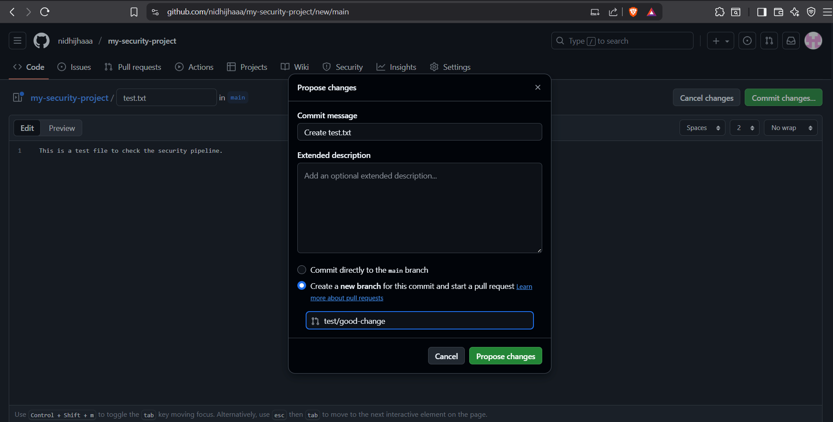

- You are now on the "Open a pull request" screen. Click the final "Create pull request" button.

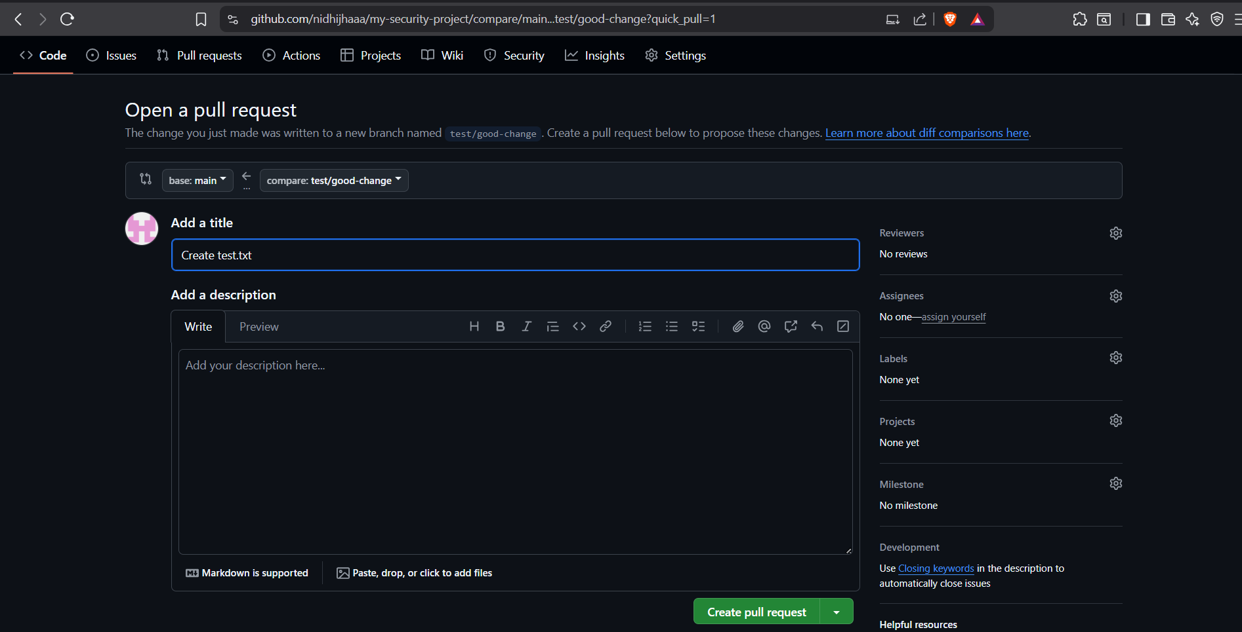

- Security Scanning workflow running

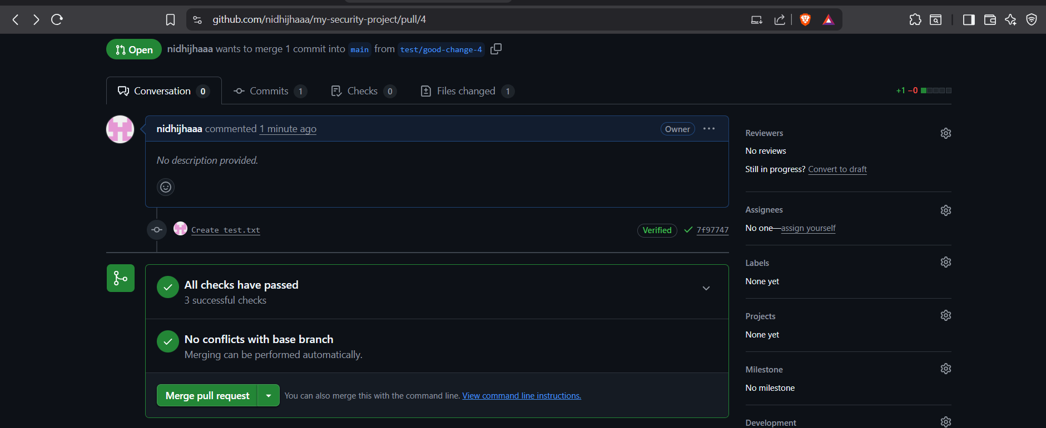

- Immediately after creating the PR, go to the "Actions" tab

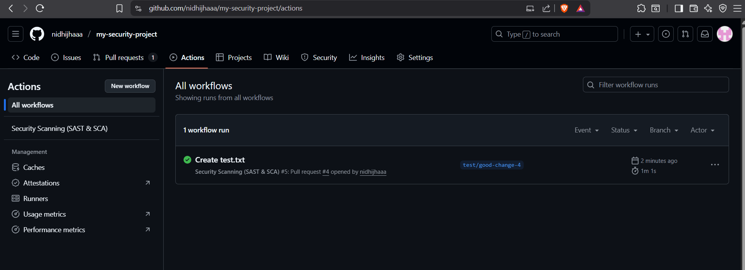

- Click on Create test.txt

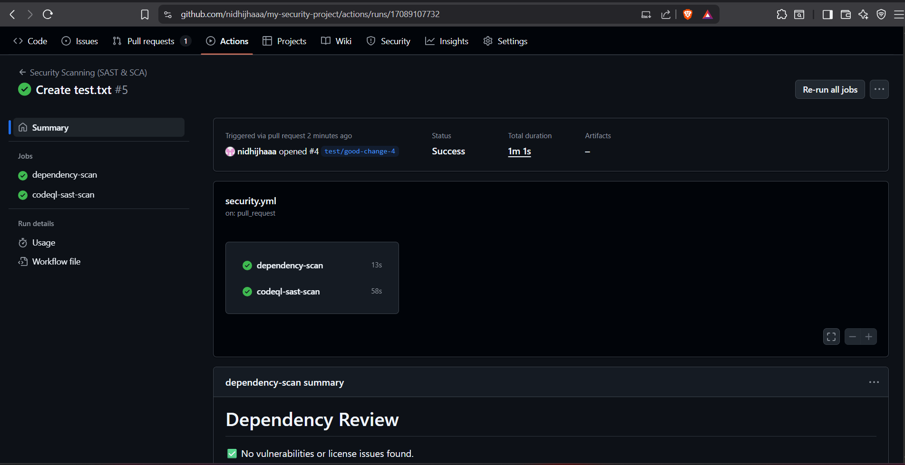

Since you only added a .txt file and didn't change package.json, the dependency scanner found no new problems. The PR will show that all checks have passed. This is the success case.

Test 2: The Bad PR (Should FAIL)

Edit the package.json file

Introduce a known vulnerable dependency. In the dependencies section, add this line:

"axios": "0.18.0"

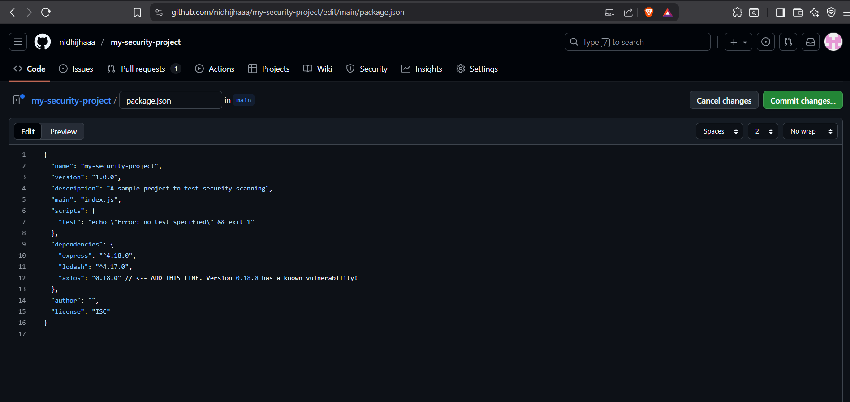

- Create a new branch for this commit..."
- Name the branch test/bad-dependency.
- Click "Propose changes".

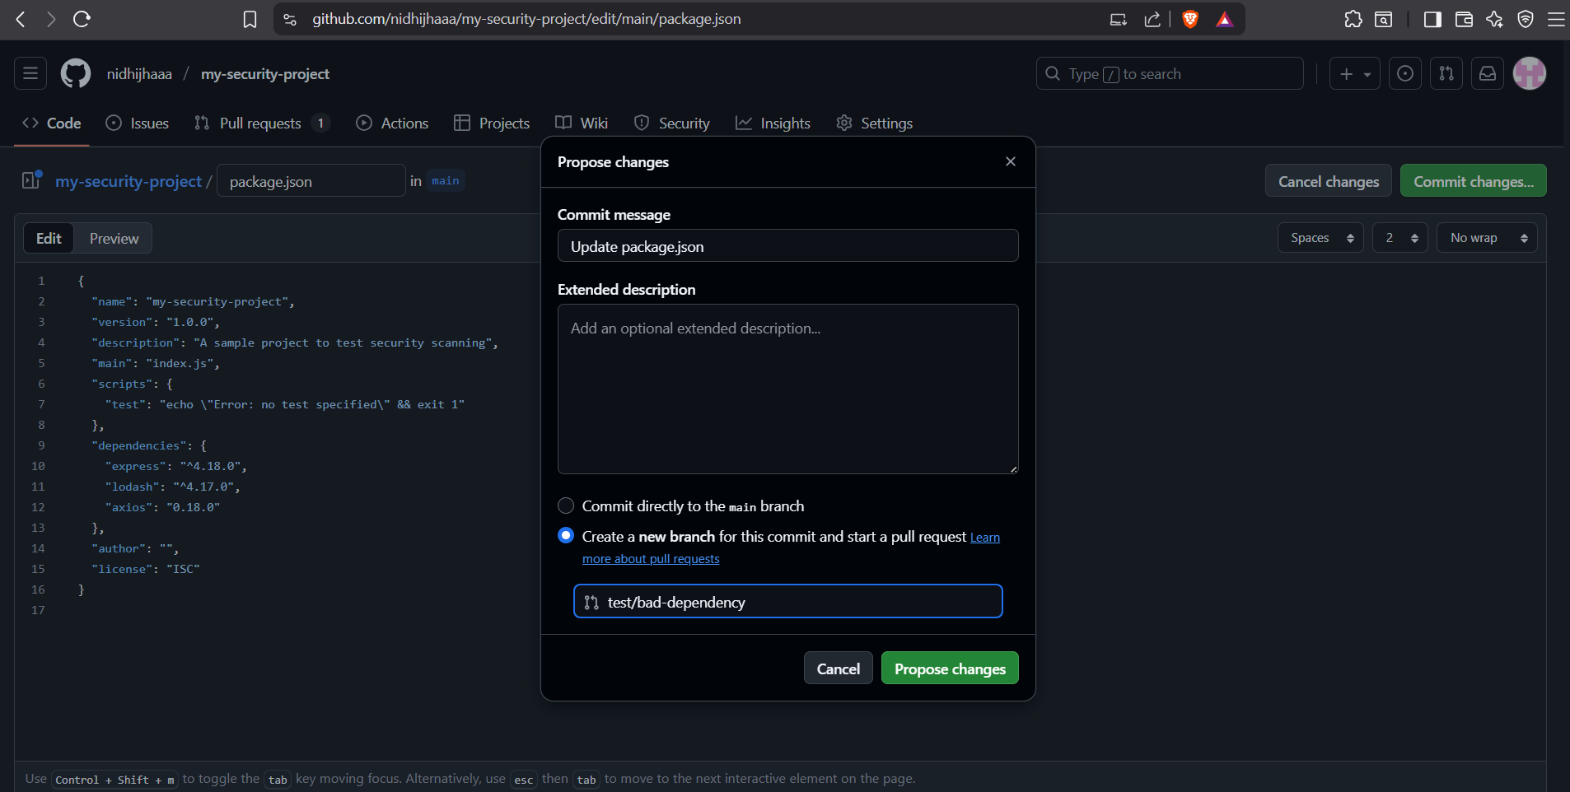

See the dependency-scan job is failed.

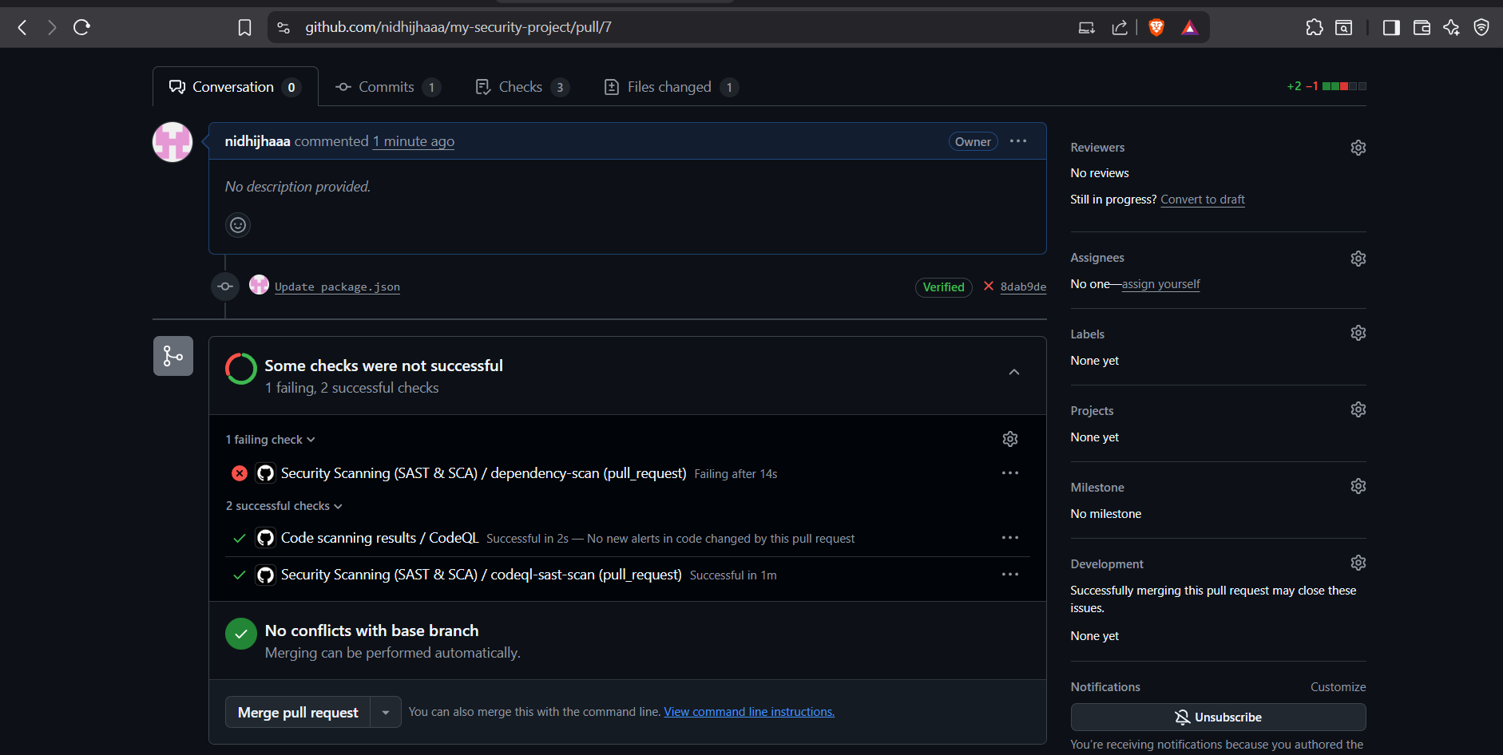

- Go to the "Actions" tab again. You'll see the workflow running.
- Now, go to your new PR. Watch the "Checks" section.
- The codeql-sast-scan might finish successfully . This is because your source code is still fine.
- The dependency-scan job will FAIL. This is exactly what we want!

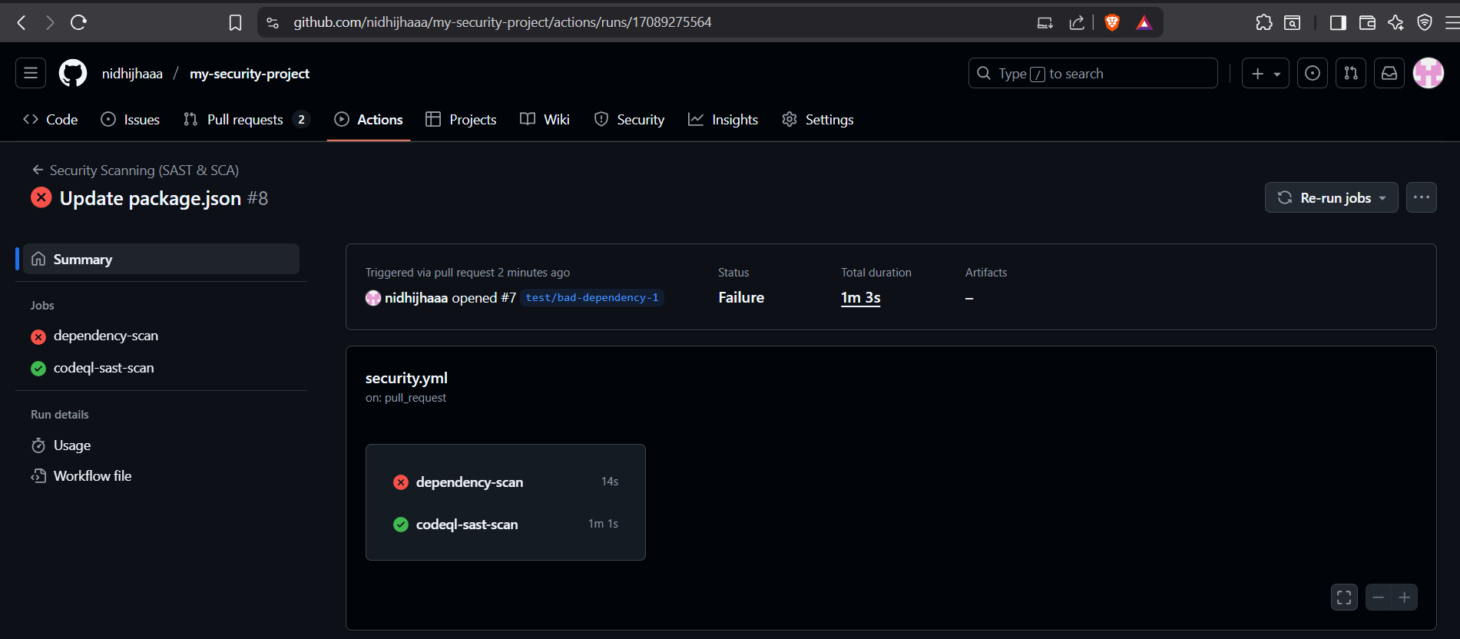

- You will see logs from the dependency-review. It will clearly list the vulnerability it found, for example:
Vulnerability found: axios - version 0.18.0
Severity: high

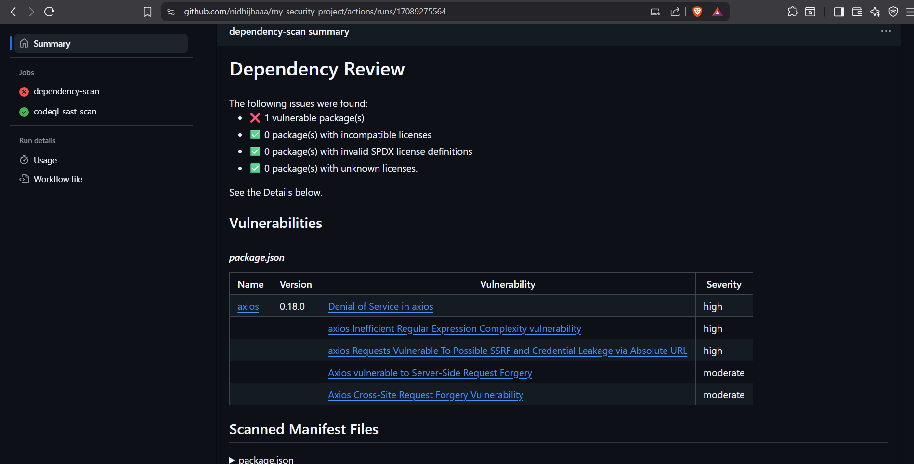

Conclusion

By following this guide, we successfully integrated automated security scanning into GitHub pipeline.

Key Takeaways:
- SCA (Dependency Scanning): Prevents vulnerable packages from entering the codebase.
- SAST (CodeQL): Detects security flaws in custom application code.
- Automation: Every pull request is scanned before merging, enforcing security at the source.
- Shift Left Security: Vulnerabilities are caught early in the development lifecycle, reducing risk and cost.

This setup ensures that your project remains secure by design, aligning with DevSecOps best practices.

